Converting Units worksheet

1. | Converting to smaller area unit
 | 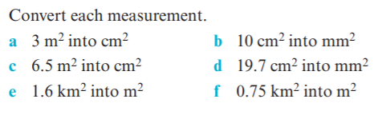
2. | Converting to larger area unit
 | 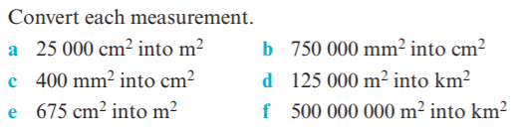
3. | Converting to smaller volume unit
 | 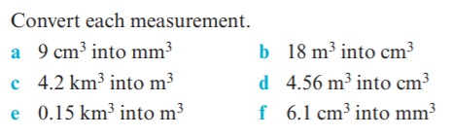
4. | Converting to larger volume unit
 | 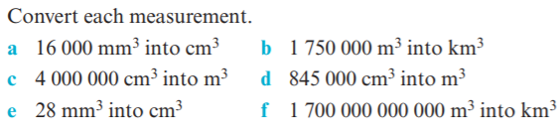
5. | Mixed questions- work with a partner
 | 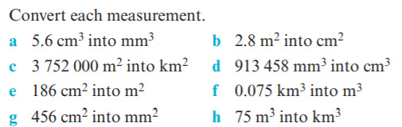

Converting Units- worded questions worksheet
1.
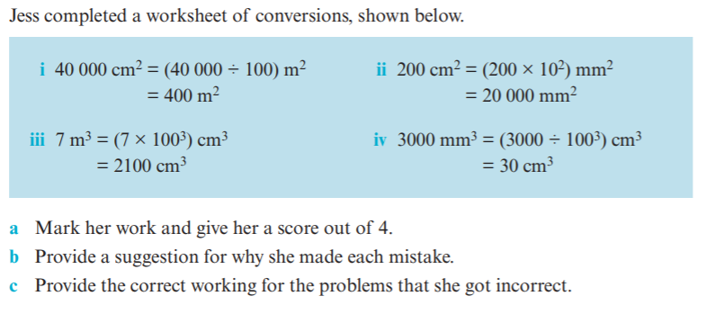

2.
